Pokhara University

Level: Bachelor | Semester – Fall | Year : 2008
Programme: BE |  | Full Marks: 100
Course: Engineering Mathematics IV |  | Time : 3hrs.

Candidates are required to give their answers in their own words as far as practicable.
The figures in the margin indicate full marks.

Attempt all the questions.

 | - State Cauchy Riemann equations and hence show that the function 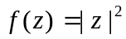 is no where analytic.  OR  Define a harmonic function and its harmonic conjugate. Show that u(x, y) = sinx coshy is harmonic and find its harmonic Conjugate v(x, y) so that the function  f(x, y) = u(x, y) + iv(x, y) is analytic | 7
 | - State the Cauchy Integral formula and by using it evaluate the following integral:  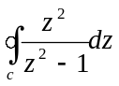, where C is a positively oriented circle |z -1| =1. | 8
 | - Find the Laurent series expansion of the function 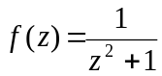 for the region 0 < |z-1| < R and determine the precise region of convergence.  OR  State Cauchy residue theorem and then evaluate  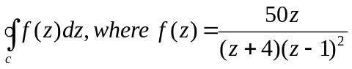  and C is a positively oriented circle |z| = 5 | 8  8
 | - Using the method of separation of variable solve the partial differential equation 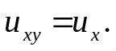 | 7
 | - Show that the solutions of the one dimensional wave equation  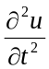= c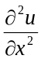 satisfying the boundary conditions u (0,t) = 0 and u(L ,t) = 0 is 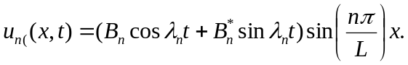 ( n = 1,2,3…)  OR  Show that the Laplacian in cylindrical polar coordinate is  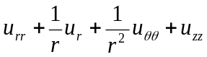 | 8  8
 | - Find the tempreture in a laterally insulated bar of length L whose ends are kept at tempreture 0, and assuming that the initial tempreture is given by  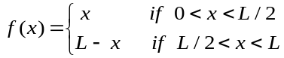. | 7
 | - Show that : 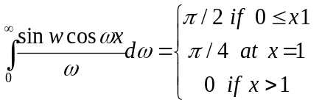 | 8
 | - Find the Fourier cosine transform of the function f(x) =e^{-ax} (a>0).  OR  Let f(x) be continuous and absolutely integrable on the x- axis , let f'(x) be piecewise continuous on each finite interval and let f(x) tends to 0 as x tends to ∞. Then  denote the Fourier cosine and sine transform of the corresponding function. | 7  7
 | - Maximize the function 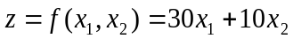  Subject to the conditions:  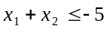, 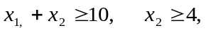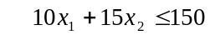. | 8
 | - Define Z- transform of a function f(t) and by using the definition find the Z- transform of : 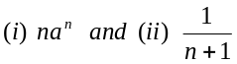 | 7
 | - State the first shifting theorem for Z transform and hence find  (i) Z(cos at) and (ii) Z( sin at) | 8
 | - Find inverse Z transform of 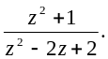  OR  Solve the difference equation | 7  7
 | Short questions:  - Find the principal argument of z = 1-i  - Write down the equation of the circle in complex form whose centre is at 1+ i and of radius 1.  - If (x ,y ,z) and 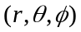 are the coordinate of the same point in cartesian and spherical polar coordinate form respectively, write down the x ,y ,z in terms of 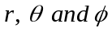.  - State the two dimensional wave equations in polar form.  - Show that where 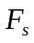 stands for the Fourier sine transform.  - Sketch the feasible region of the inequalities | 5×2

